OKLAHOMA BUSINESS ETHICS CONSORTIUM
Oklahoma City Chapter ~ June 11, 2008
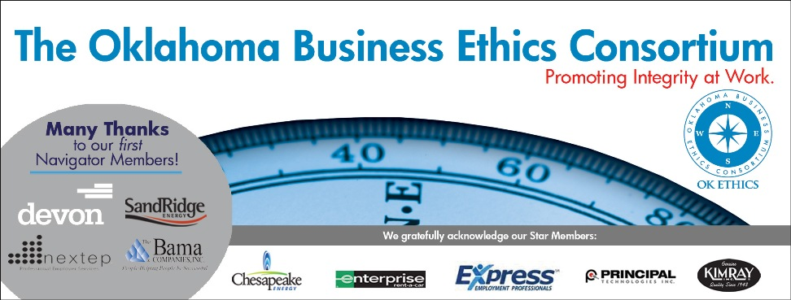
VISION: To be recognized as a statewide (and national)
forum for promoting business ethics.

- KUDOS & WELCOME Bob Byrne, Boeing
President of OkEthics’ Foundation
Guiding Principle: HONOR
We express gratefulness to our hosts, sponsors and speakers.
The hardest arithmetic to master is that which enables us to count our blessings.
– Eric Hoffer
  - Bobby Redinger of Cole & Reed – We commend her initiative in providing this month’s meeting agendas.
  - Greg Byers of Sinclair Broadcasting Group – We cannot do these events without him! As Registration Chair, Greg organizes the lists every month with a conscientious eye for detail and a servant leader’s heart.
  - Mary Kay Huggard & the Principal Technologies team are the best! They support us each month with their registration efforts and make sure that nobody is kept waiting in line.
  - Joshua Jantz of the Institute of Basic Life Principles can always be counted on to prepare our name tags.
  - Connie Barwick – Maximum Multi Media Creations for the pre-meeting Power Point presentations and website. She has also continued to help us in the transition to new bookkeeping services.
  - Tess Smith – Walker Companies for donating the great OkEthics banner.
  - Behind the scenes, our dedicated volunteers who serve on the Board and are the heart of this organization!

SPECIAL ANNOUNCEMENT: SCHOLARSHIP EXTENDED TO JUNE 20
OCU’S MEINDERS SCHOOL OF BUSINESS

- Discussion Questions

      - Based on an excerpt from the
Globe and Mail Workplace Ethics 101:November 5, 2003:
The new boss is getting acquainted with each staff member by taking each individual to lunch. Now, it’s your turn. He indicates that he is impressed with your work and asks you about the rest of the team. There is a less-than-conscientious slacker in the department. Do you tell the boss?

Please help promote Oklahoma values of integrity at work:
Join OkEthics by going online to www.okethics.org

      - Based on an excerpt from The Good, The Bad and the Difference by Randy Cohen:
For some time, you’ve tried to salvage a contract employee who has been conducting some specialized technical research for you. His performance is mediocre at best and you’re worried that he may negatively impact other people in your department. There is no legal reason to keep him past the contract expiration, but you recently learned that he and his pregnant wife are buying a new house. There’s still work to be done even though the contract is up. What should you do?

III. INTRODUCTION OF GUEST SPEAKERS Shannon Hiebert, President of OkEthics;
Vice President of Human Resources, Enterprise Rent-A-Car

Tere Bettis, Vice President
Director of Human Resources
Coppermark Bank

Jeanette Rice,
Senior Vice President
Corporate and Human Resources
American Fidelity Assurance

Carolyn Shockey, PHR
Director of Human Resources
Norman Regional Hospital

IV. UPCOMING EVENTS Shannon Warren, Founder, OkEthics
Advance reservations required for all events ~
Visit our website at www.okethics.org or call 858-2233;
Member discounts apply regardless of location.
Norman Chapter –
June 18 – Stillwater Sheriff Norman McNickle, “Decisions: Right, Wrong or Ethical”

OKC Chapter
July 9 – “Ethics in the Media” with KFOR’s Kevin Ogle
August 13 – CPE Symposium at OCU’s Meinders School of Business
Featured Presentations (So Far) – Recommended for 1 hour CPE - Ethics
- Confronting Ethical Issues: Cheryl Doellefeld- Barth
- Islam & Modern Ethical Dilemmas: Dr. Imad Enchassi, Imam & President of Greater OKC Islamic Society
- Creating & Cultivating an Ethical Culture: Tom Hill, CEO of Kimray
- Corporate Chaplains Combat Ethical Risks: Fred Imel, CPA; Panelists include Chaplains Shad Glass (Kimray), Jon Cook (Corporate Care, Inc.) and Joe Bynam ( Executive Chaplain Service)
- Ethics & Organizational Performance: Dr. Cappy Leland, CEO of Performance Dashboard
- Keeping on the Straight & Narrow During Organizational Change:
Todd Lisle, Partner, BKD, Inc.
- Ethical Materiality: Melinda Stinnett, Stinnett & Associates

Tulsa Chapter
June 26 – Clifton Taulbert

V. OTHER RELATED PROGRAMS:

Character First Institute - June 26 – “Decisiveness in the Workplace”

Oklahoma City Business and Community Leaders' Luncheon

Registration Information: Call 815-0001, or visit www.characterok.org

OkEthics is very grateful for the support of over 600 individual members statewide:
For a complete listing of sponsors, please visit our website at www.okethics.org
See also additional sponsors listed on our website.

NAVIGATOR MEMBERS – $7500 level
- BAMA COMPANIES (Tulsa)
- DEVON Energy
- NEXTEP (Norman)
- SANDRIDGE ENERGY
Many thanks to our Navigator sponsors for their continued support! Shows support at highest level of commitment in terms of funding ($7500) and participation.

OKLAHOMA STAR MEMBERS
-- $5000 level
- Chesapeake Energy
- Express Personnel Services
- Enterprise Rent-A-Car
- Kimray, Inc.
- Principal Technologies
The Oklahoma Star membership of $5000 Includes 8 memberships; prepaid for all OkEthics events. Shows support by allowing OkEthics to post logo on Home page of website and promotional materials.

HORIZON MEMBERS – $2500 level
Dollar Thrifty Automotive Group (Tulsa); Helmerich & Payne (Tulsa); Norris (Tulsa);
The Rowland Group (Tulsa); Metro Technology Centers (OKC); SemGroup (Tulsa);
Valir Health (OKC)

PLEASE HELP US CONTROL COSTS BY LEAVING YOUR NAME TAG HERE!

General Disclaimer: Members of the Oklahoma Business Ethics Consortium frequently share information concerning various issues and developments that may have legal implications. The discussions, commentary, and handouts at Consortium meetings or presentations to other organizations are for general informational purposes only. They cover only some aspects of the subject topic, and do not constitute a complete legal analysis of the topic or how it might apply to any particular set of facts. Before taking any action based on information presented during a Consortium event, participants are encouraged to consult a qualified attorney. The observations and comments of presenters at Consortium meetings and networking are the views and opinions of the presenter and do not constitute the opinion or policies of the Consortium or any of its members. Presenters are respectfully requested to avoid profanity, preaching, politics and self-promotion during their lectures. It is the responsibility of participants to demonstrate applicability of each program for demonstration of earned CPE credits.

